Model-based Control for Earthquake Simulation on a Seismic Shaking Table

Afonso Henrique
Earthquake Engineering and Structural Dynamics Unit (NESDE/DE)
Laboratório Nacional de Engenharia Civil (LNEC)
Lisbon, Portugal
ahenrique@lnec.pt
Miguel Ayala Botto
IDMEC, Instituto Superior Técnico, Universidade de Lisboa, Portugal
ayalabotto@tecnico.ulisboa.pt
Fernando Oliveira
Modelling and Rock Mechanics Unit (NMMR/DBB)
Laboratório Nacional de Engenharia Civil (LNEC)
Lisbon, Portugal
fvoliveira@lnec.pt

Abstract— This paper presents two model-based controllers for the accurate simulation of earthquakes using an experimental seismic shaking table. While reproducing recorded earthquake ground-motion time histories is often straightforward, analysing their effects on built structures through scaled laboratory experiments remains a challenging task. A primary concern is ensuring that the vibration response spectrum of the seismic shaking table accurately matches the target earthquake signal. During the experiments, the dynamic response of the mounted coupled physical structure must not interfere with the seismic shaking table motion intended to reproduce the earthquake excitation. This requirement can be formulated as a disturbance rejection problem, for which two model-based control strategies are proposed: a Filtered PID (PID-F) controller and a Linear Quadratic Integral (LQI) controller. In both approaches, the identification of the dynamic model of the combined system — the shaking table platform and the mounted coupled structure — is required, for which the two-stage closed-loop identification method is used. The performance of both controllers is validated experimentally on a small-scale seismic shaking table using eight benchmark real earthquake ground-motion records. The results show that the performance of both the PID-F and LQI controllers outperform the standard Online Iteration (OLI) method currently in use at the Laboratório Nacional de Engenharia Civil. Among the two proposed approaches, the LQI controller achieves the best results by minimizing the squared error between the target and measured response spectra of the earthquake reference signal. Overall, these results open the possibility of exploring new control techniques for reproducing simulated earthquakes in laboratory-scale experimental setups.
Keywords— Earthquake Engineering, Control Systems, Closed-loop Identification,

Introduction
Earthquakes are among the most catastrophic natural events, frequently causing severe loss of life, extensive property damage, and significant socio‑economic disruption. One of the most effective ways to reduce seismic risk is by decreasing the structural vulnerability of the built environment, which can be assessed through experimental techniques such as shaking‑table testing.
Common seismic setups consist of a physical structure coupled to a stiff shaking‑table platform that is driven so as to reproduce the desired ground‑motion time history (reference signal). This experimental concept was introduced in the 1940s and became widespread during the 1960s. Early systems relied on mechanical profiled cams to generate the excitation, but servo‑hydraulic systems soon became the standard solution ([1],[2],[3]). At the Laboratório Nacional de Engenharia Civil (LNEC) a Goodmans model VG-108 electrodynamic shaker attached to a movable table was installed in the 60s to perform seismic tests [4]. A uniaxial seismic shaking table (ST1D) was developed and installed, consisting of a 3 m × 2 m horizontal steel platform and a vertical platform body driven by a hydraulic actuator supplied by a dedicated oil‑hydraulic circuit ([5], [6]). During this period, adaptive control strategies were developed, implemented, and validated both on a small scale shaking table and on the ST1D, for tracking reference earthquake spectrum (frequency domain), iteratively ([7],[8]). Increasingly demanding requirements for reproducing seismic excitation along all three directions motivated the development of the triaxial shaking table (ST3D), which has been installed and operational at LNEC since the mid‑1990s [4]. The reproduction of earthquakes on a seismic shaking table depends strongly on: i) the hardware (mechanical and electrical system), which usually has limitations and therefore can distort the reference signal and; ii) the control system, whose performance is highly sensitive to the adopted control strategy and tuning. The hydraulic and control system supplier, MTS Systems Corporation (MTS), provided several control strategies: i) Three-Variable Control (TVC), also known in control theory literature as state variable control [9], which combines the displacement, velocity and acceleration feedback [1]; ii) Adaptive Harmonic Cancellation (AHC), suitable for sinusoidal signals (fixed frequency or sweep); iii) Adaptive Inverse Control (AIC) [10], suitable for non-sinusoidal signals on linear systems; iv) Amplitude/Phase Control (APC), suitable for sinusoidal signals (fixed frequency and sweep) and predominantly linear systems, which is often used in conjunction with AHC to reduce distortions in nonlinear systems; v) Online Iteration (OLI), suitable for nonlinear systems and non-sinusoidal waveforms. This last strategy is the most appropriate for earthquake engineering applications, as structures may exhibit nonlinear behaviour or sustain damage during the tests. OLI is currently the control method implemented at LNEC’s ST3D.
Seismic shaking‑table control strategies are typically based on inverse model controllers. The offline generation of the drive signal is obtained through the inverse dynamic model of the system to be controlled. This drive signal is then used to feed a linear controller, e.g. a Proportional‑Integral‑Derivative (PID) controller, using the actuator feedback signals (displacement, velocity, or acceleration) ([1], [11]). PID controllers remain widely used in most testbed setups, including shaking‑table and hybrid testing platforms [12]. This is the basis of the OLI control strategy. Alternative control approaches have been proposed in the literature, including: i) Acceleration Trajectory Tracking Control (ATTC) [13]; ii) displacement feedforward-feedback controller using an optimal controller [14]; iii) Model-based feedforward-feedback controller for acceleration tracking [15]; iii) minimal control synthesis (MCS) strategy, which is feedback-feedforward adaptive control strategy including the inverse model in line with the reference signal [16].
The OLI strategy currently implemented at LNEC’s seismic shaking table has several limitations: i) the PID controller parameters are fixed and cannot be adapted under test to the characteristics of the reference signal; ii) the approach requires the offline computation of the drive signal to be fed into the system; iii) the procedure is iterative, often requiring multiple drive‑signal updates to achieve the target response, which increases testing time and may induce additional damage to the coupled structure. In this paper, an alternative control methodology for shaking‑table testing is presented. Two model-based controllers are proposed using a dynamic model obtained from the two‑stage closed-loop system identification method [17]: i) a PID-F controller, i.e. a PID with a filter on the derivative term, tunned to maximize the bandwidth while maintaining a unitary frequency response function (FRF); ii) an LQI controller, i.e. an optimal controller augmented with an integral of the tracking error, whose weighting terms are tunned with the Nelder-Mead simplex optimization algorithm [18], such that the optimal state feedback law minimizes the mean squared error between the target and the output response spectra. Eight earthquake records [19] are used to evaluate the performance of the proposed controllers on a small‑scale seismic shaking table. Numerical simulations demonstrate that the performance of the proposed controllers outperform the OLI control approach, with the LQI controller exhibiting the best performance. These results validate the effectiveness of the proposed control approach besides confirming previous results obtained with the numerical model of the ST1D shaking table [11].
This paper starts in Section I with a brief introduction to the seismic shaking table control problem, summarizes previous work, describes the proposed methodology outlining the control strategies to improve the system performance. The control strategy currently in use and the experimental set‑up available at LNEC are described in Section II, followed by the detailed presentation of the control methodologies in Section III and the corresponding results in Section IV. The paper concludes with the main findings and outlook for future developments.

LNEC’s Shaking Table Test process & Control system
The current control strategy implemented in the LNEC’s seismic shaking table tests is based on the OLI algorithm. It involves the iterative synthesis of a drive signal with progressively increasing severity, aiming to ensure that the platform accurately reproduces the response spectra of the reference signal, i.e., the target earthquake (Fig. 1). The experimental test procedure consists in testing the structure to a series of test steps starting with a low severity earthquake (scaled earthquake) and then repeat for the same earthquake at a higher severity (higher amplitude), until a defined amplitude is reached which usually corresponds to the original amplitude of the earthquake – reference severity.
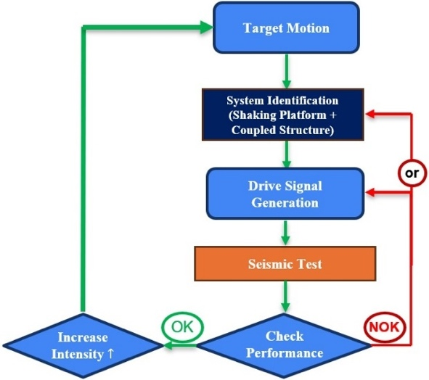
- Current LNEC’s seismic experimental test procedure
At each test step the structural damage is accessed and, before starting a new test step, the system's transfer function is identified using a band-limited pink noise input signal (with a slope of -10dB/decade). This transfer function is then used to generate the drive signal for each test step. Throughout this process, the amplitude of the reference signal increases progressively, and it is expected that the coupled physical structure will enter a non-linear regime, either due to the behaviour of some of its components or the damage accumulated during the various tests. At each test step, the system's performance is evaluated by comparing the response spectrums of the reference signal with the platform (Fig. 2).
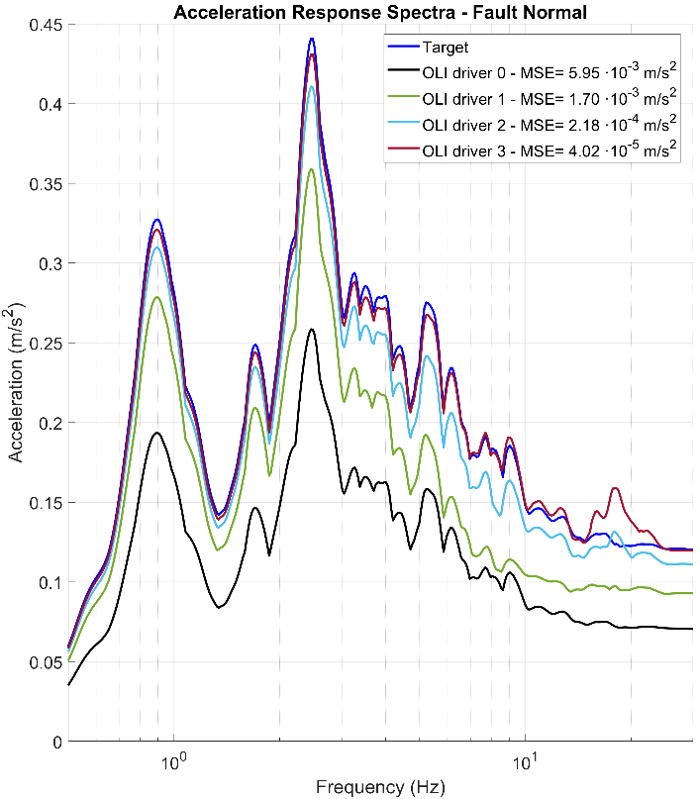
- Acceleration response spectrum evolution for the scaled L’Aquila seismic signal using four iteratively generated drive signals.
The response spectrum is a fundamental concept in earthquake engineering and structural dynamics, as it represents the maximum response (such as displacement, velocity, or acceleration) for each natural frequency of a single degree of freedom mass-spring-damper system subjected to the ground motion. It represents how structures respond to a specific earthquake ground-motion record and is used to characterize earthquake severity.
Consequently, different earthquake time histories can correspond to the same response spectrum, meaning they have the same severity. However, it is not always possible to achieve satisfactory performance with the command signal synthesized initially, and it may be necessary to generate more than one command signal and carry out additional test steps. This procedure, although necessary to fit the spectrum, it induces additional damage to the structure. Additionally, physical limitations inherent to the equipment, namely with regard to the finite field of displacement, velocity and acceleration, must be duly considered during the tests.
To overcome these limitations a control methodology for shaking-table using an optimized linear controller, the identified model of the system and earthquake recorded is being proposed. The performance of the system will be evaluated with two candidate controllers: a PID-F and an optimal LQI controller.
An experimental facility comprising a small-scale seismic shaking table with dedicated hardware and software is used to validate the methodology. The measurement and control chain is depicted on Fig. 3 consisting on: i) Shaking Table, including a small-scale shaking table installed on a fixed base, along which it rolls over, driven by a Goodmans model 390A electrodynamic shaker, and a Linear Variable Differential Transformer (LVDT) measures the relative displacement of the platform; ii) Conditioning and Control unit, with a hardware rack comprising all required signal conditioning and control components, including sensor signal conditioners and a National Instruments PXI Real-Time Controller integrated with a CompactRIO system featuring a Virtex-5 FPGA, enabling autonomous real-time execution of control and acquisition tasks; iii) and, Data Acquisition System comprising a host PC, where the experimental setup is configured using the NI LabVIEW environment, including the implementation and supervision of the control strategy, the data acquisition set-up, as well as the measurement and visualization of the experimental results.
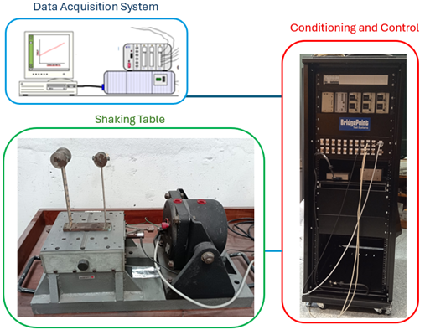
- Experimental facility
One key advantage of this system framework is the modularity, since both data acquisition system and the condition and control rack can be deployed with other experimental setups. In particular, the system can be reused with the ST1D shaking table, where the proposed control strategies will be subsequently validated.
The approach proposed in this paper considers the full system as a closed-loop control system schematically illustrated in Fig. 4, comprising of two blocks: i) a given controller, which in this paper is a PID-F controller or an optimal LQI controller; and ii) the controlled system, consisting of the shaking-table hardware, including its mechanical and electrical components, together with the top-mounted coupled structure (also referred as the physical model). The controller is designed to minimize the error between the output signal y, corresponding to the shaking-table motion, and the reference signal r, corresponding to the earthquake signal.

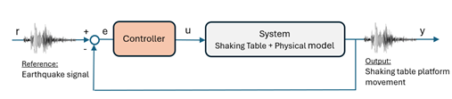
- Seismic shaking table control loop
The control strategy currently implemented at LNEC is the OLI control approach. For the majority of applications, the PID controller parameters are tuned in advance for a specific test configuration and subsequently kept fixed throughout most experimental campaigns.

Methodology

Foreword
This section details the system identification method used, the controllers design, and how the performance evaluation is measured. Firstly, the two-stage closed-loop identification method [17] is addressed. Then the open-loop driver signal design procedure currently used at LNEC is described. This method will serve as a baseline for different controller performance comparison. Finally, the two proposed controllers are designed.

System identification
A dynamic model identification of the plant (shaking table and the mounted coupled structure) is needed for tunning the controllers. To this end an identification experiment is carried out using a band-limited pink noise driver signal, with amplitude of approximately ±4 mm, with the controller set with proportional gain K_{p}=10 V/m, and data acquisition at 200 Hz. A sampling period of 5 ms is used throughout. The imperative of running experiments under closed-loop control poses additional challenges for identifying the plant. To address the particularities of a closed-loop identification, the two-stage method [17] illustrated in Figure 5 is applied.

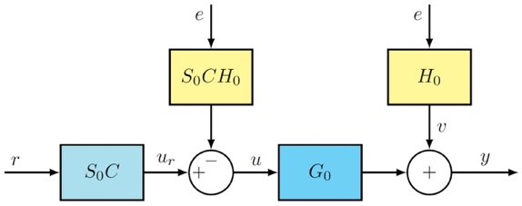
- Block diagram illustrating the two-stage method, with S₀C being a Hammerstein-Wiener model to better represent the real system dynamics with control action saturation (C – controller; S₀ – sensitivity function; G₀ – model plant; H₀ – noise model; e – white noise; u_{r} – noise free control action).

Firstly, the sensitivity function with controller, S₀C, is identified by fitting a linear FIR model with 100 parameters (the order of the model needs to be high enough to reproduce the noise-free control action, and high variance is not of concern). Then a Hammerstein-Wiener model is defined, using the previously identified FIR model as the linear block, and with the output nonlinearity equal to that of the physical system (saturation of the control action at known values), resulting in a more refined model for the sensitivity function. This function is then used to compute the noise-free control action u_{r}, from which (by being uncorrelated with the output y) the plant G₀ can now be estimated without bias introduced by the controller in the feedback loop.

Control Strategies
LNEC’s driver signal iterative adaptation process: This control technique is known as Online Iteration (OLI) [MTS Systems], as it iteratively modifies the command input on an individual sample-by-sample basis until the system response is close to the target.
This method compensates the next drive signal with a drive correction signal which is computed from filtering the previous iteration error with the inverse model of the closed-loop frequency response function. The closed-loop frequency response function (FRF) is estimated via a nonparametric identification method by spectral analysis. To this end, the user interface of the driver iteration program allows many different settings for the identification. For the simulations of the OLI method, the identification used the same experimentally acquired data with the band-limited pink noise, and the FRF identification settings use Hanning window with the number of windows set to 8192 and 97% overlap, and the FRF mode is set to H3. During the driver adaptation process, settings such as correction factor and maximum frequency compensation are adjusted as needed, while the coherence threshold is left at 90%.
The closed-loop transfer function used in the simulations of the OLI method was estimated by direct identification (from signals “r” and “y”, resorting to Fig. 4), and its frequency response is shown in Fig. 6.
PID-F control strategy: Following the experimental test procedure at LNEC (Fig. 1), where the identification is carried out each time the target signal is scaled up, one possible straightforward improvement would be to update the controller tune accordingly using this information. Another simple enhancement would be to add a filtered derivative term to the PI controller (making it a PID-F), since this should be of simple implementation in the existing version of the control software, as it is merely an extension of the existing controller structure, while it allows for more tuneability.
LQI control strategy: The controllable canonical form state space representation of the plant transfer function obtained via the closed-loop two-stage method identification is used in the minimization of the following LQI cost function:
$J\left(x\left(t\right),u\left(t\right)\right)=\sum_{0}^{∞}{{x\left(t\right)}^{⊺}Q}x(t)+{u\left(t\right)}^{⊺}Ru(t) dt$ (1)
where Q and R have appropriate dimensions, with R=1 and Q being a diagonal matrix where each parameter was found via Nelder-Mead simplex algorithm [18] in order to minimize the acceleration response spectrum MSE for the seismic signal on test, computed for 100 logarithmically spaced points between 0.1Hz and 30Hz. The optimal state feedback control law is given by u(t) = K [x(t) x_{i}(t)]^{T}, with x_{i}(t) being the integral of the tracking error.
The simulations with the PID-F and the LQI controllers use the plant model resulting from the two-stage identification.

Performance evaluation
A set of recorded earthquake ground-motion time histories covering a wide range of seismic characteristics are considered in this study, namely [19]: i) 1940 Imperial Valley earthquake, El Centro Fault Normal (FN) and Fault Parallel (FP) records; ii) 1992 Erzikan earthquake, Erzikan North-South (NS) and East-West (EW) record; iii) 1995 Kobe earthquake, Kobe NS and EW records; iv) 2009 L’Aquila earthquake; v) 1994 Northridge earthquake, Newhall FN and FP records; vi) 1994 Northridge earthquake, Rinaldi FN and FP records; vii) 1994 Northridge earthquake, Sylmar FN and FP records; viii) 1976 Friuli earthquake, Tolmezzo record. To ensure that the imposed inputs remained within the displacement capacity of the shaking table, appropriate scale factors were found by taking the quotient of the maximum desired displacement of 4 mm with the maximum displacement of any direction of the seismic signal (rounded to 3 decimal places) and then applied to the ground-motion signals.
The performance of each control method is evaluated through the acceleration and displacement response spectrum mean squared error (MSE) for every input action described in the previous section. The displacement and acceleration response spectra is computed from 0.1 Hz to 30 Hz for 500 logarithmically spaced points.

Results

System identification and controller tunning
The closed-loop frequency response obtained with each control method is shown on the Bode plot of Fig. 6 for a particular earthquake ground-motion history.
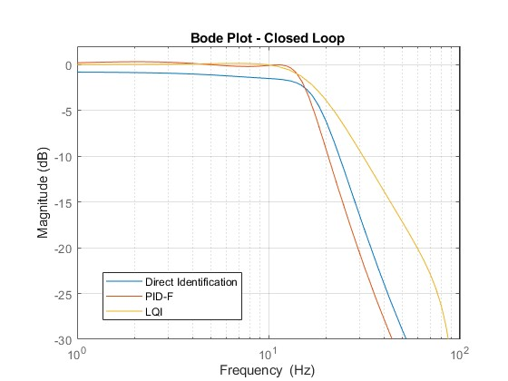
- Shaking table control loop frequency response with controllers optimized for the Tolmezzo earthquake.
The frequency responses clearly highlights the meriths of the PID-F and LQI controllers in contrast witht the OLI method: a larger bandwidth is obtained while maintaining a unitary gain at lower frequencies. This directly translates to improvements in the response spectrum, which will meet the target on the first run, instead of requiring several iterations.

Summary of results
The results obtained show how the tunning/optimization can improve significantly the performance of the system. It can be observed in Fig. 7 and Fig. 8 for acceleration and displacement response spectra for the Newhall earthquake, respectively, that the PID-F controller closely matches the target response, the LQI achieves an even closer match, whereas the OLI method remains further from the target even after the third drive iteration.
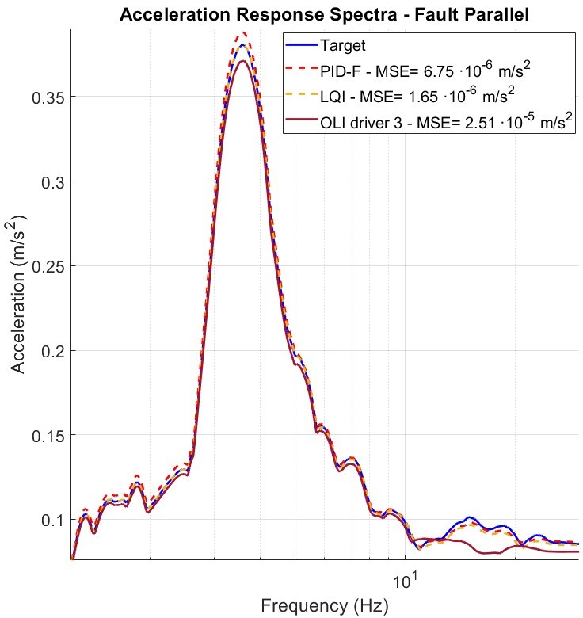
- Comparison of the acceleration response spectrum for a scaled down Newhall (FP) seismic signal
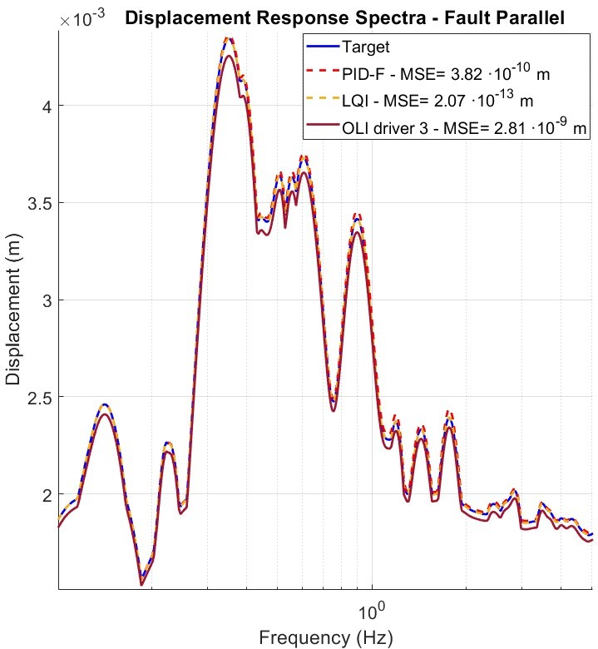
- Comparison of the displacement response spectrum for a scaled down Newhall (FP) seismic signal

The results obtained for the remaining earthquakes exhibit the same trend, as shown in Fig. 9 and Fig. 10.
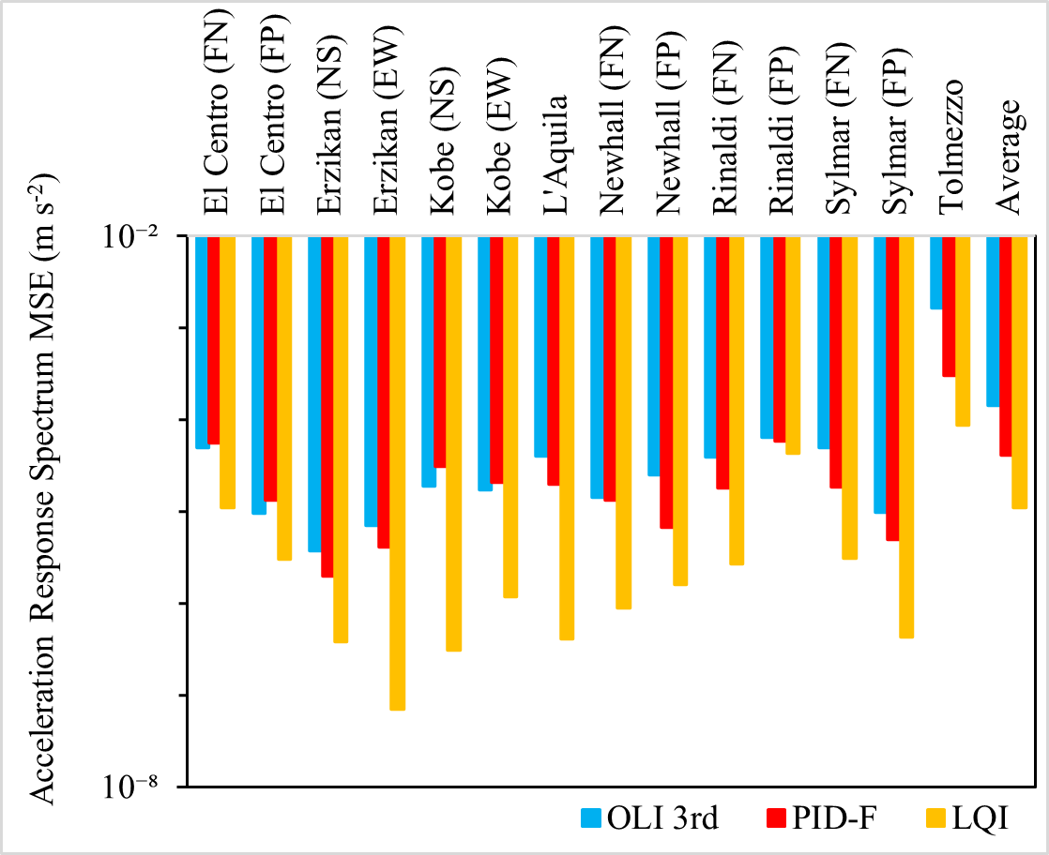
- Comparing OLI, PID-F and LQI acceleration spectrum performance for 8 recorded earthquake ground-motion time histories
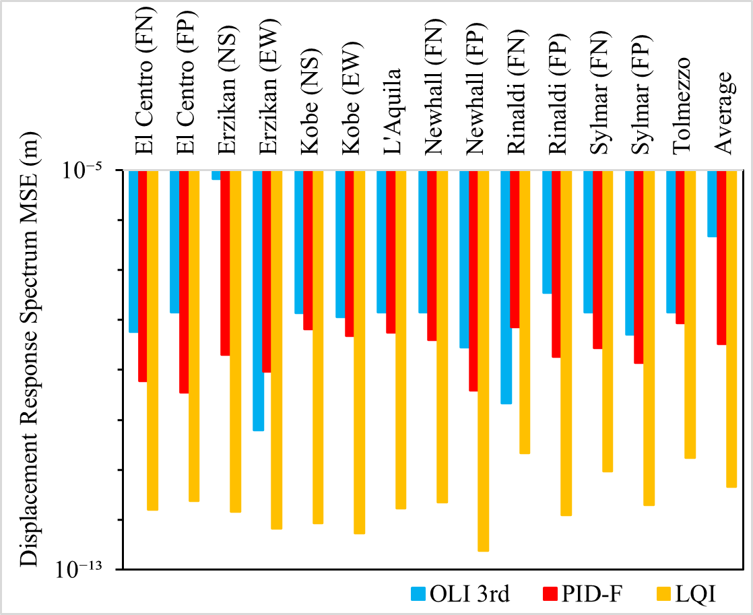
- Comparing OLI, PID-F and LQI displacement spectrum performance for 8 recorded earthquake ground-motion time histories

This analysis confirms the benefits of using the proposed control methods, consistently confirming the LQI as having the best performance.

Conclusions & Outlook

This paper presents an improved solution to the current OLI method used at LNEC for the experimental reproduction of simulated earthquakes using laboratory seismic shaking-table setups. Based on the proposed model-based controllers and the application of the two-stage closed-loop identification method for plant identification, the PID-F and LQI controllers were shown to reproduce the target response spectra across the entire frequency range of the earthquake signal more accurately than the standard OLI method. The proposed controllers also require less user intervention and provide a more systematic approach to the control problem, with the LQI controller achieving the best performance by a significant margin across all simulated earthquake ground motions.
Given the nature of seismic shaking-table testing, the physical structures under investigation are often susceptible to plastic deformation, partial failure, or significant nonlinear behaviour that cannot be detected during low-intensity identification experiments. As a result, non-negligible shifts in dynamic properties and the excitation of previously unknown modes may occur during testing. These phenomena should be addressed by the control system, therefore, future work should focus on the implementation of adaptive online identification methods to support the development of nonlinear control algorithms.
The next stage of this research consists of implementing the proposed controllers on a real physical system, namely a small-scale shaking table, in order to verify and validate the performance improvements achieved in simulation. Subsequently, the methodology is intended to be implemented on LNEC’s uniaxial shaking table (ST1D), where the same analysis will be carried out to assess its effectiveness on larger-scale systems. This future stage aims to evaluate the scalability, robustness, and practical applicability of the proposed control strategies under more demanding experimental conditions.

Acknowledgment

The authors acknowledge LNEC for its financial support through the research fellowship under the LNEC Research Programme Modelação do Comportamento Estrutural- Mestr, and Fundação para a Ciência e a Tecnologia (FCT) for its financial support via LAETA (project https://doi.org/10.54499/UID/50022/2025).

References

- S. J. Chapman, M. S. Williams, A. Blakeborough, “Laboratory testing of structures under dynamic loads: an introductory review”. Philos Trans A Math Phys Eng Sci; 359 (1786): 1651–1669, 15 September 2001. https://doi.org/10.1098/rsta.2001.0860
- E. C. Carvalho, “Seismic Testing of Structures”, 11th European Conference on Earthquake Engineering, Balkema, Rotterdam, 1998.
- P. X. Candeias, A. A. Correia, G. G. Tekeste, “Shake Table Testing Techniques: Current Challenges and New Trends,” In: Chastre, C., Neves, J., Ribeiro, D., Neves, M.G., Faria, P. (eds), Advances on Testing and Experimentation in Civil Engineering. Springer Tracts in Civil Engineering. Springer, 2023. https://doi.org/10.1007/978-3-031-23888-8_8
- T. Emílio, R. T. Duarte, F. Carvalhal, C. O. Costa, C. T. Vaz, M. R. Corrêa, “The new LNEC shaking table for earthquake resistance testing”, Memória 757, LNEC, Lisboa, 1989.
- R. Bairrão, Duque, Simulador Sísmico Uniaxial - Descrição e operação, Relatório LNEC, 94/1998 - C3ES/SES, LNEC, Lisboa, 1998.
- P. Castro, Mesa Vibratória Vertical (Projeto), Relatório LNEC, Obra 76/53/1077, LNEC, Lisboa, June 1978.
- F. Carvalhal, Simulation of Seismic Disturbances Using Adaptive Control, MSc Thesis, Victoria University of Manchester, Institute of Science and Technology, October 1974.
- F. Carvalhal, Controlo Adaptativo na Simulação de Solicitações Sísmicas, Tese para Especialista LNEC, STG/DPA, Proc. 76/13/5588, Lisboa, Janeiro 1979.
- K. Ogata, Modern Control Engineering. 5th Edition, Pearson, Upper Saddle River, 2010.
- B. Widrow, E. Walach, Adaptive Inverse Control: A Signal Processing Approach, Institute of Electrical and Electronic Engineers, July 2007. DOI:10.1002/9780470231616
- A. Henrique, M. Ayala Botto, F. Oliveira, “Development of control strategies for earthquake reproduction on uniaxial shaking table,” 13º Congresso Nacional de Mecânica Experimental – CNME2026, Universidade do Porto, Porto, 2026.
- G. G. Tekeste, Real-Time Hybrid Simulation including a Shaking Table – Development and Application to Soil-Structure Interaction. PhD Thesis, University of Aveiro, 2021.
- N. Nakata, “Acceleration trajectory tracking control for earthquake simulators,” Engineering Structures, 32(8), 2229–2236, 2010. https://doi.org/10.1016/j.engstruct.2010.03.025
- B. M. Phillips, B. F. Spencer, “Model-based feedforward-feedback actuator control for real-time hybrid simulation,” Journal of Structural Engineering, 139(7), 1205–1214, 2012. https://doi.org/10.1061/(ASCE)ST.1943-541X.0000606
- B. M. Phillips, N. E. Wierschem, B. F. Spencer Jr, “Model-based multi-metric control of uniaxial shake tables,” Earthquake Engineering & Structural Dynamics, 43(5), 681–699, 2014. https://doi.org/10.1002/eqe.2366
- D. P. Stoten, E. G. Gómez, “Adaptive control of shaking tables using the minimal control synthesis algorithm,” Philosophical Trans. Of The Royal Society 359(1786):1697-1723, Setember 2001. DOI:10.1098/rsta.2001.0862
- P. M. J. Van Den Hof, R. J. P. Schrama, “An indirect method for transfer function estimation from closed loop data,” Automatica, Volume 29, Issue 6, Pages 1523-1527, 1993. DOI: 10.1016/0005-1098(93)90015-L.
- J. C. A. Lagarias, Reeds, M. H. Wright, P. E. Wright. “Convergence Properties of the Nelder-Mead Simplex Method in Low Dimensions.” SIAM Journal of Optimization. Vol. 9, Number 1, 1998, pp. 112–147. DOI:10.1137/S1052623496303470
- S. Narasimhan, S. Nagarajaiah, E. A. Johnson, H. P. Gavin, “Smart base-isolated benchmark building. Part I: problem definition,” Structural Control and Health Monitoring 13:573–588, 2006. DOI: 10.1002/stc.99

